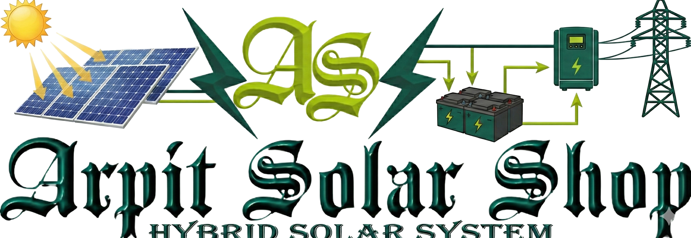

**Solar Hybrid Power System Quotation**

**👤 Customer Details**

* **Customer Name:** {name}
* **Mobile Number:** {phone}
* **Project Location:** {project_location}
* **Customer Type:** {customer_type}

**📄 Quotation Details**

* **Quotation Date:** {quote_date}
* **System Capacity:** {system_size} kW Hybrid Solar System
* **Product:** {product_name}

**⚡ Site Information**

* **Current Monthly Bill:** ₹{monthly_bill}
* **Estimated Roof Area:** {estimated_area_sqft} sq. ft.

**🔧 System Technical Specifications**

**⚡ Inverter & Storage**

* **Inverter Capacity:** {inverter_capacity} kVA Servotech Hybrid Inverter
* **Battery Backup:** {battery_capacity} kWh Servotech/INTU Battery

**☀️ Solar Modules**

* **Module Wattage:** {module_wattage} W
* **Number of Modules:** {number_of_modules}

**🏗️ Mounting Structure**

* **Structure Type:** {structure_type}

**🔌 Protection & Distribution**

* **ACDB Quantity:** {acdb_qty}
* **DCDB Quantity:** {dcdb_qty}

**🌍 Earthing & Lightning Protection**

* **Earthing Rods:** {earthing_rod_qty}
* **Earthing Chemical:** {earthing_chemical_qty} bags
* **Lightning Arrester:** {lightning_arrester_qty}

**🧵 Cabling & Wiring**

* **AC Cable:** {ac_wire_mtr} meters
* **DC Cable:** {dc_wire_mtr} meters
* **Earthing Wire:** {earthing_wire_mtr} meters

**💰 Pricing Details**

|  |  |
| --- | --- |
| Description | Amount |
| **Base Price (Excl. GST):** | ₹{base_price} |
| **GST @ 8.9%:** | ₹{gst_amount} |
| **Price per kWp (Incl. GST):** | ₹{price_per_kwp} |
| **TOTAL PAYABLE AMOUNT:** | ₹{total_price} |

**GST Breakup**

* **70% of Base Price:** Taxed at 5% GST
* **30% of Base Price:** Taxed at 18% GST
* **Overall Effective GST Rate:** Approximately 8.9%

The GST calculation is designed to ensure compliance with regulations and provide a clear understanding of the tax components involved in your purchase.

**📝 Terms & Conditions**

* This quotation is valid for 15 days from the date of issue.
* Prices are inclusive of supply, installation, and standard civil work.
* Net metering charges (if applicable) are to be paid directly to DISCOM.
* Additional civil work, elevated structure, or long-distance cabling will be charged extra after site survey.
* System includes remote monitoring and standard manufacturer warranties:
  + Solar Panels: 25 years performance warranty
  + Inverter: 5–10 years
  + Battery: As per manufacturer policy
* Installation as per MNRE guidelines and industry safety standards.

**🤝 Thank You for Choosing Clean Energy!**

We look forward to powering your home/business with reliable solar energy.

**Authorized Partner:** Arpit Solar Shop   
**Contact:** 9044555572   
**Website:** Arpit Solar Shop   
**Email:** support@arpitsolar.com

☀️ Let’s Go Solar Together!